# Утверждена

от №

СХЕМА ГРАНИЦ ПУБЛИЧНОГО СЕРВИТУТА

# Объект: "Распределительный газопровод низкого давления от ГРПШ №2 по ул.

Победы д. Волот Волотовского района Новгородской области. 2-й Этап"

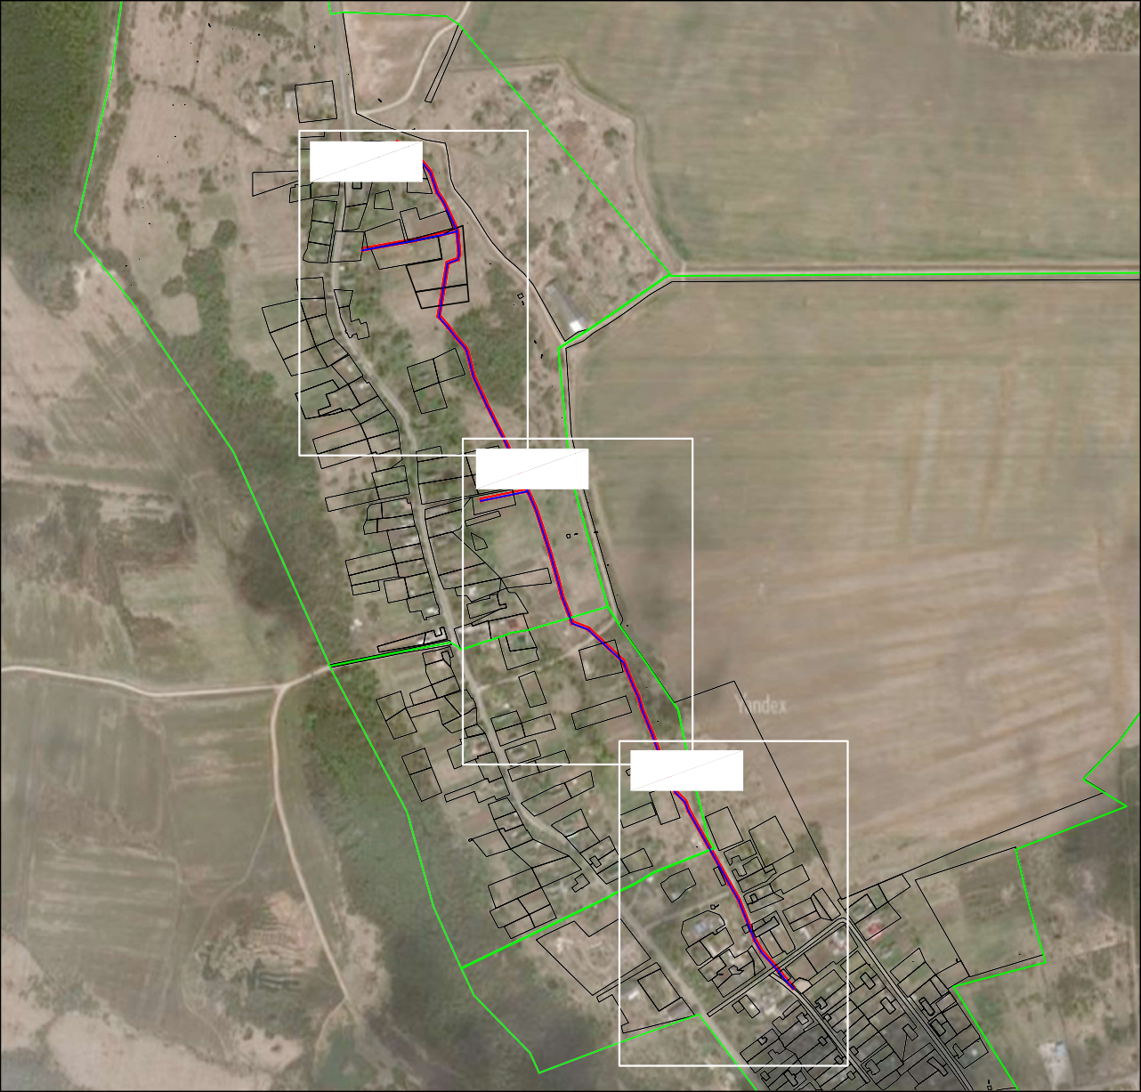

:40

:16

:11

:68

:41

:12

:37

:190 58 38

57

:14

37

:43

59

::68

36

:15

:44

:29

:189

:46

:8

:7

56

:355

39 :40

55

:26

:6

:114

:34

:41 :131

53:04:0050302

:35

:36

:42

:9

:38

::69

:225

:62

:57

:22

31

64 ::65

63 32

:25

53:04:0050302

:54

:24

66

65 30

:26

29

:33

::1

:56

:193 :64

:14:870

:55

:2 :188

:55

:93

:19

:30

::67

Лист 3

60 35

:48

:78

61 34

:49

:47

:50

:21

:32

::66

:51

:58

62 33

:23

:70 :11

:56

:46 :85

:32

:33

:18

:61

:59

:127 ::8888((12)) :60

:58 :57

:87

:48 :86

:47

:65

:84

:36

:35

:82 :34

:126

:347(2)

:350

:77

:9

:1:21704

:67

:49

:338

:66

:339

:91

:213

:90

:111

:95

:43

:12

:125

:14

:13

:45

:29 :44 :75

:7

:74 :6 :76

:5

:15

:50

:54

:30

:16

:8

:79

:31

:55 :110

:17 :80

:9:4102

:127

:53

53:04:0050301

:2

:207

:64

:215

:113

:69

:5

:63

:38

54

:4

:130 :130

41 :72

:130

:39

:129

:109

:3474(51)

50 46

49 4:7224

48

:351

5

51

::108

:345

:51 ::107

44 ::106

:10 :214

:23 :223

:103

:21

:101

::112

:52

:116

:115 :37

42 :118

53 :117

43

52

:28

:206

:359

:1

:25

:3

:305

:315 9 8

::136

90

89

::111

91 7

:189

:83 96

95

:51

98 99 6

97 93 92

94

::128

:46

::127

:304

::112

:85

:47

::137

100

88 10

:130

86

:38

12

87

:37

11

:79

5

:40

:1

:129 :132

:39

:316

:81

:41

53:04:0050303

::110

:139 ::116

:91 :92

Ли

104

:54

1

::115

:125

:124

:153

::138

::123

::117

:122

::140

::121

::120

::119

:118

:126

:96

:102

4

101

:87

:49

:113

:48

:94

:52

13

14

:103 3

102

:179

:99

2

103:104

ст 1

:89

:50

::114

:13

:10

:9

::99

:12

72 23

:63

:11

:66

53:04:0050303 73 22 :4 :135 :98

:61

:16

:65(1)

:15

:65(2)

:122

74 21

:67

:18 :17

70 25

28

68

:56

27

26

69

:5

:100

::97

:58

:57 :58

:58

:59

:312

:7

:8

71

24

:60

83 15

:28

:27

::134

16

82

17

81

:29

:75

:303 :32 :302

:31

:133

:25

:77

:33

:78

:36

:131

84

85

:35

Лист 2

77

76 :69

:20

78 20

75

:71

:19

79

:72

19 :96

67

:21

:73

:74

:23

:22

:26

80

18

Условные обозначения: Масштаб 1:10 000

1 - характерная точка контура, сведения о которой позволяют однозначно определить её на местности

* вновь образованная часть контура, сведения о которой достаточны для определения её

местоположения

* существующая часть контура, имеющиеся в ЕГРН сведения о которой достаточны для

определения её местоположения

* граница кадастрового квартала
* проектируемый газопровод

53:16:0031001 -номер кадастрового квартала

:49

:54

:50

:48

:47

:91 :92

:89

:94

:87

:96

104

1

:99

:125

2

103:104

:103

102

:102

3

:126

4

101

5

100

:179

:46

:85

:83 96

:305

:304

97

94

98 99

92

93

:127

6

:51 95

:189

91 7

0

9

89 8

:128

:315 9

:41

:39

:36

:37

:35

:81

:79

:33

53:04:0050303

:77

:316

88 10

11

87

86

:78

12

13

85 14

84

83 15

:1

:129 :132

:

:303 :32

:302

:31

:29

16

:75 82

17

81

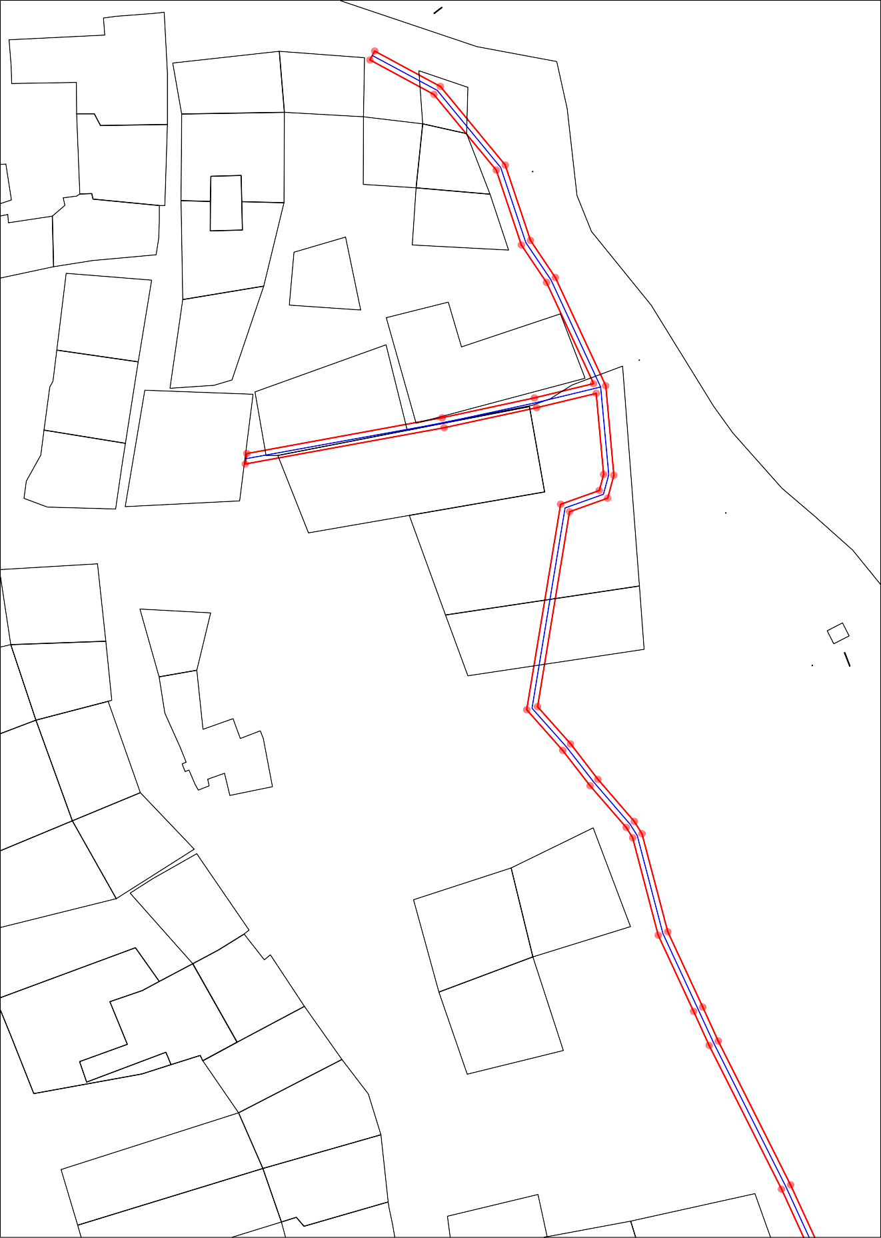

:28

:26

:27

:25

18

80

:22

18

80

:74

:72

19

79

78 20

:96

77

76

:65(2)

:66

:69

75

74

53:04:0050303

21

73 22

72 23

:4 :135

:97

:98

:61

:55

:59

:57

:58

:58

:56

:58

:55

:60

71 24

70 25

69 26

27

68 28

67

:99

:100

:101

:56

:57

29 :1

66

65 30

:54

22

53:04:0050302

31

64 :65

63 32

21

:19

:51

:49

:50

:58

62 33

61

:66

34

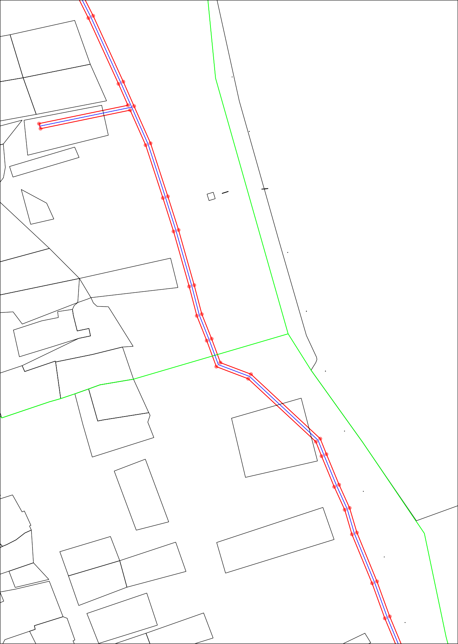:78

:48

:47

35

:67

60

35

60

:67

:189

:37

:190

:68

36

59

37

58

38

57

:35

53:04:0050302

:26

:69

:68

:114

39

55

56

:42

:41

:40

:39

:225

:131

:355

53:04:0050301

:9:4102

41 :72

54

:38

:69

:53

:215

:113

:

:127

:25

:115 :116 :37

42

:118

:206

:1

:23

:223

53

52

:28

:117

43

44

:214

:52

:

:106

:103

:51105 45

:347(1)

:67

:351

:127

:21

:70

:11

50 46

49

48

4:7224

:66

:84

:65

:36

:104

:77

:9

:347(2)

:350

:18

:17

:82

:126

:80

:35

:34

:

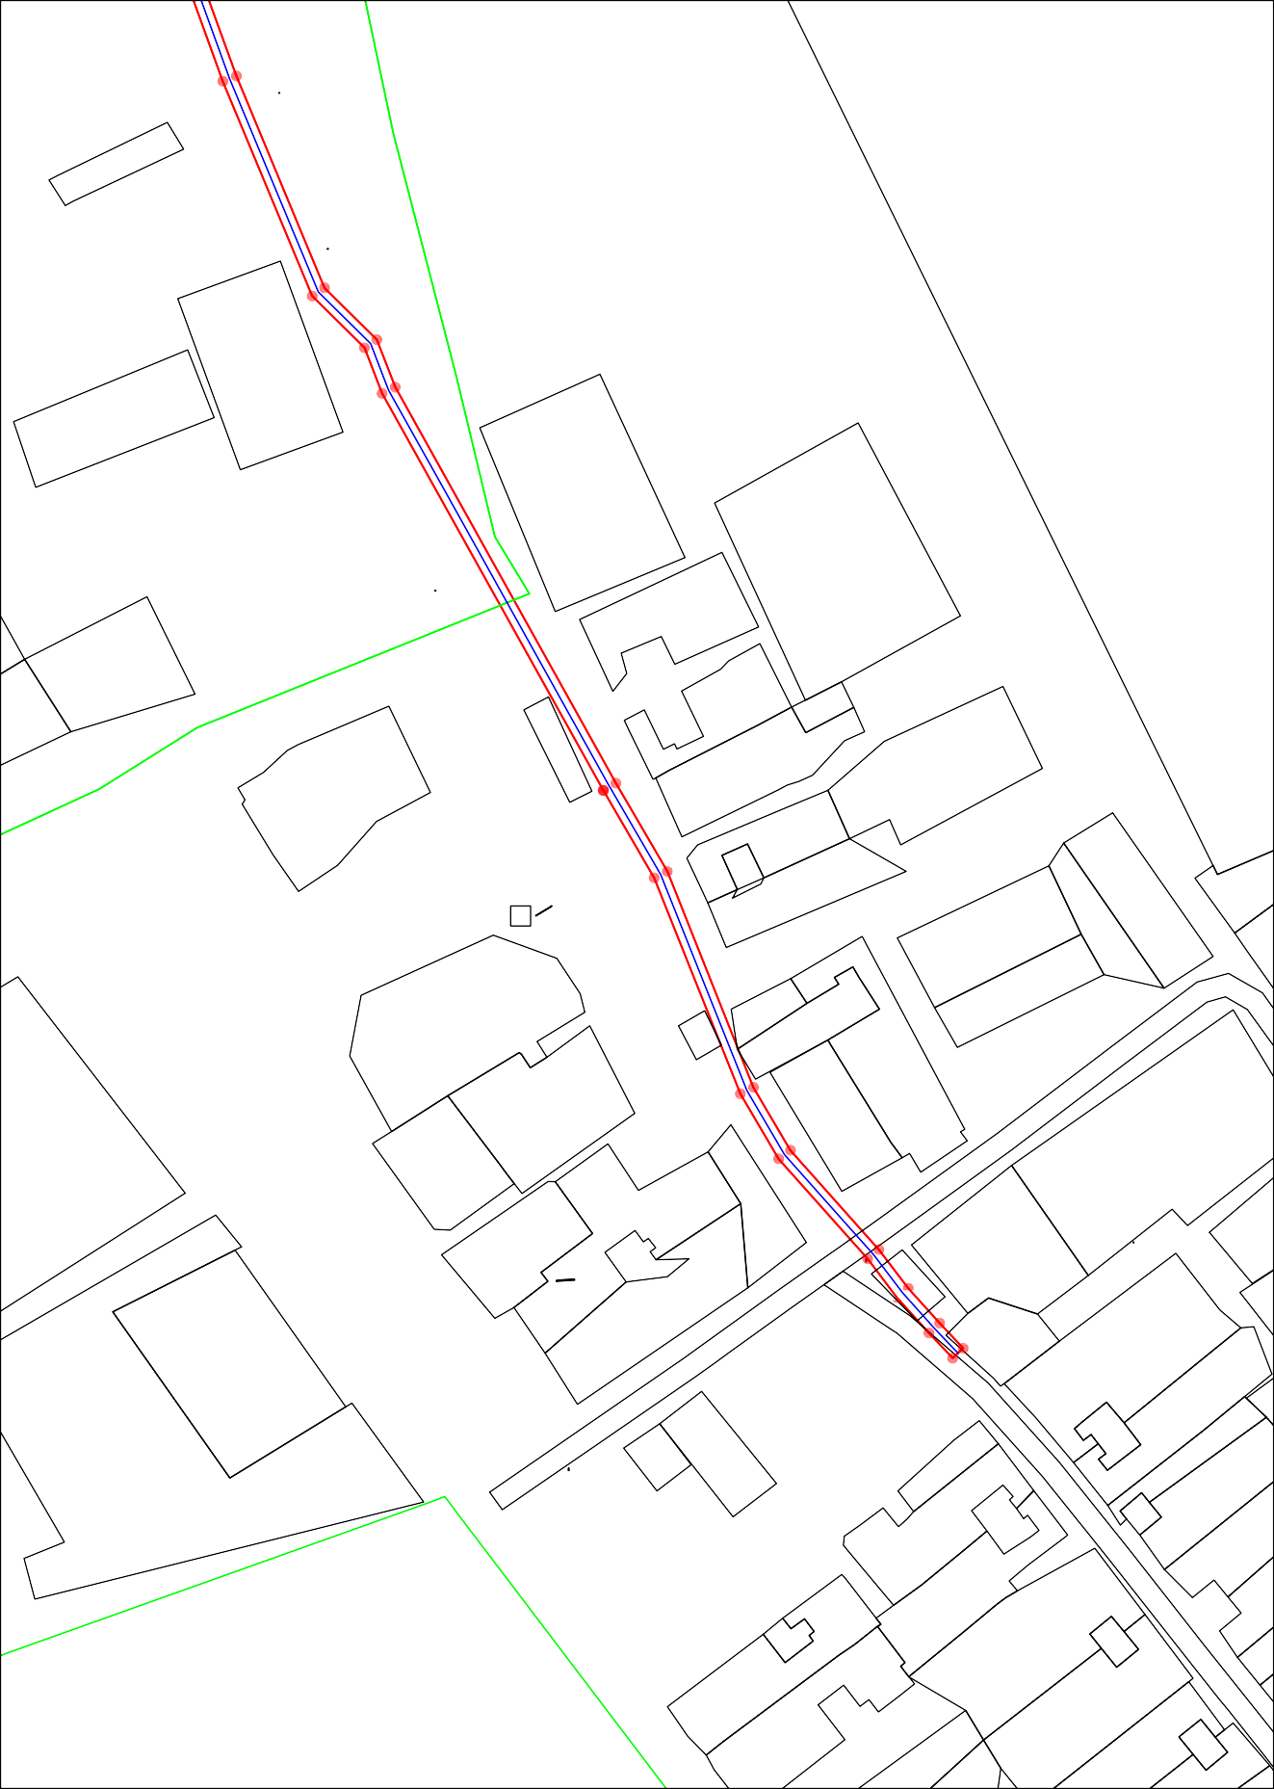:8 :16

:15

:90